**AMERICAN INTERNATIONAL UNIVERSITY-BANGLADESH**

408/1, Kuratoli, Khilkhet, Dhaka 1229, Bangladesh

|  |  |  |
| --- | --- | --- |
| Titel :Computer Network |  |  |
| Assignment No:1 |  | Date of Submission:7-4-2025 |
| Course Title:CN lab |  |  |
| Course Code: CNE2203 |  | Section:D |
| Semester:SPRING |  | Course Teacher: Dr. Rajarshi Roy Chowdhury |

**Declaration and Statement of Authorship:**

1. I/we hold a copy of this Assignment/Case-Study, which can be produced if the original is lost/damaged.
2. This Assignment/Case-Study is my/our original work and no part of it has been copied from any other student’s work or

from any other source except where due acknowledgement is made.

1. No part of this Assignment/Case-Study has been written for me/us by any other person except where such collaborationhas been authorized by the concerned teacher and is clearly acknowledged in the assignment.
2. I/we have not previously submitted or currently submitting this work for any other course/unit.
3. This work may be reproduced, communicated, compared and archived for the purpose of detecting plagiarism.
4. I/we give permission for a copy of my/our marked work to be retained by the Faculty for review and comparison, including review by external examiners.
5. I/we understand thatPlagiarism is the presentation of the work, idea or creation of another person as though it is your own. It is a formofcheatingandisaveryseriousacademicoffencethatmayleadtoexpulsionfromtheUniversity. Plagiarized material can be drawn from, and presented in, written, graphic and visual form, including electronic data, and oral presentations. Plagiarism occurs when the origin of them arterial used is not appropriately cited.
6. I/we also understand that enabling plagiarism is the act of assisting or allowing another person to plagiarize or to copy my/our work.

Group Name/No.:

|  |  |  |  |  |
| --- | --- | --- | --- | --- |
| **No** | **Name** | **ID** | **Program** | **Signature** |
| 1 | Shraboni Biswas Naboni | 22-47701-2 | BSC | naboni |

|  |  |  |
| --- | --- | --- |
| ***Faculty use only*** | | |
| FACULTYCOMMENTS | **Marks Obtained** |  |
|  |
|  |
|  | **Total Marks** |  |
|  |
|  |

**Lab1**

***PC to PC connection***

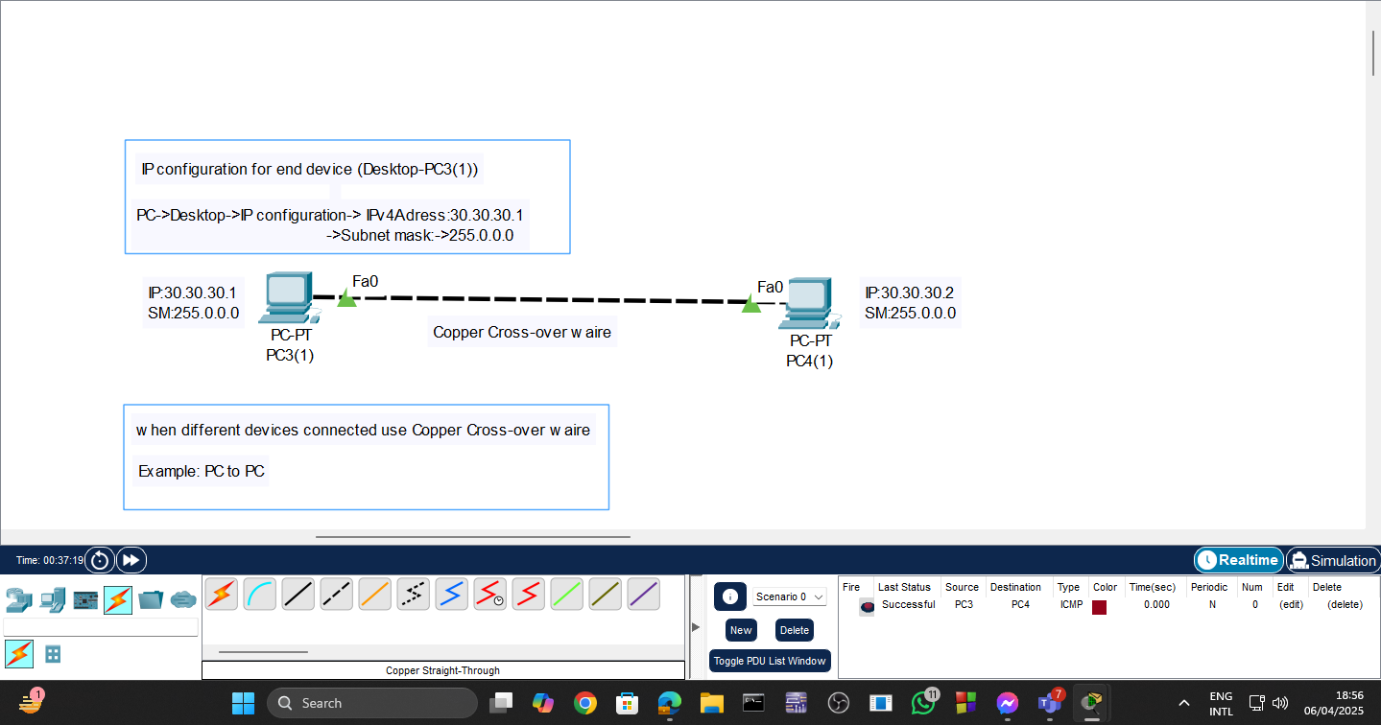

***PCs connected via a hub***

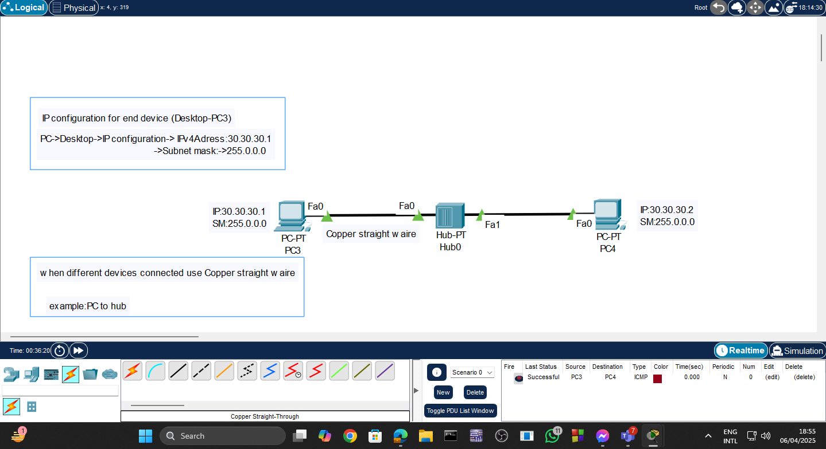

***2PC --- HUB--- 2PC***

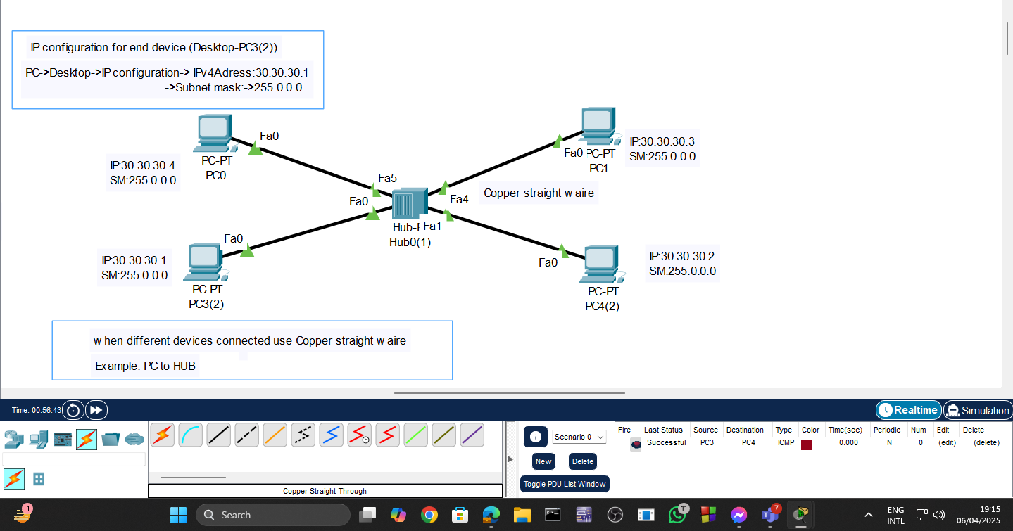

***Two PCs connect to Hub1, which links to Hub2, where two more PCs are connected.***

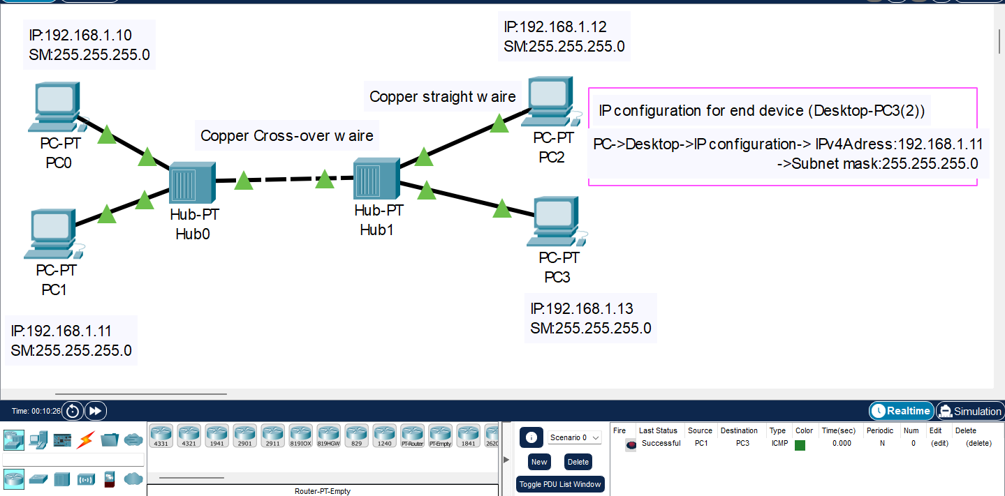

***Multiple pc(8) connected with single switch***

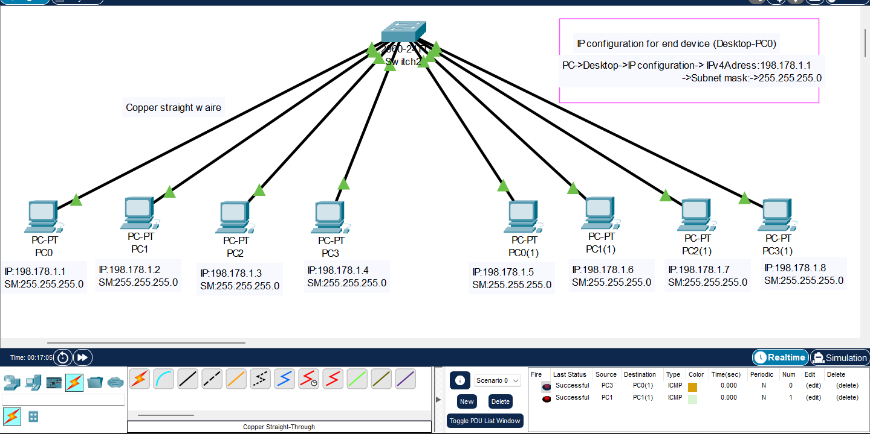

***Four PCs connect to Switch1, which links to Switch2, where four more PCs are connected***

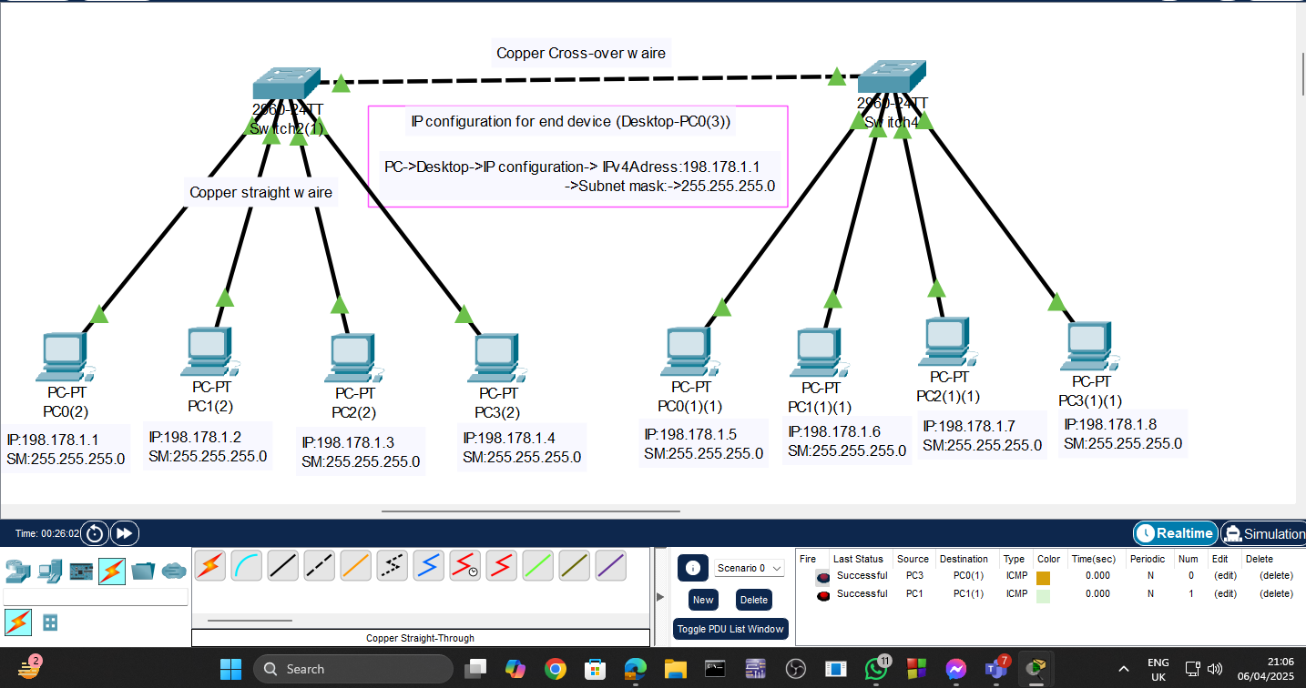

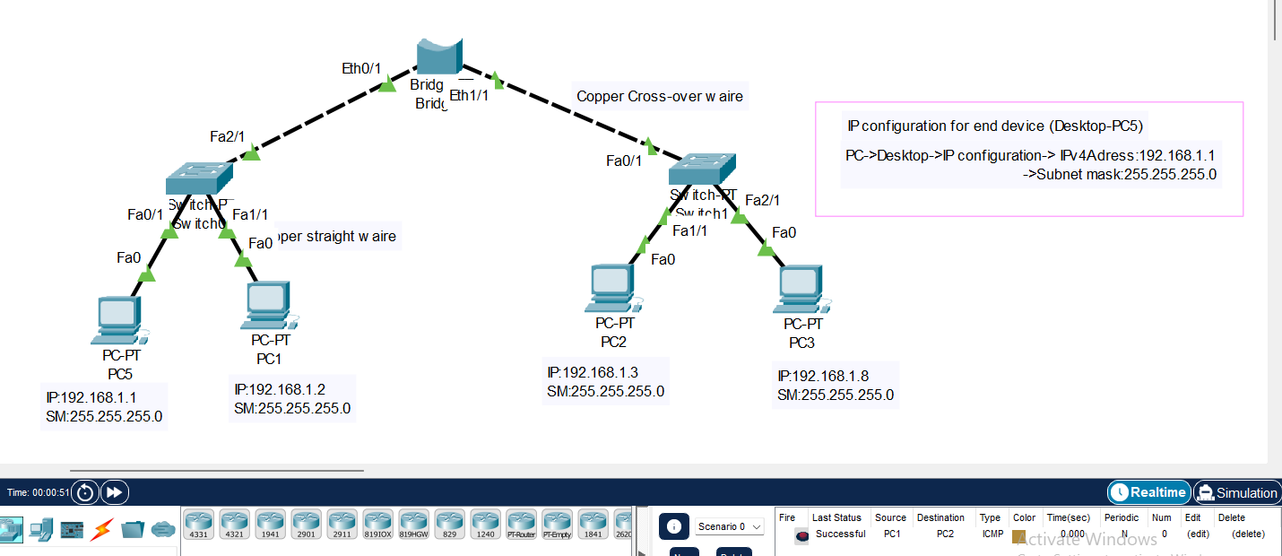

***Wireless connection***

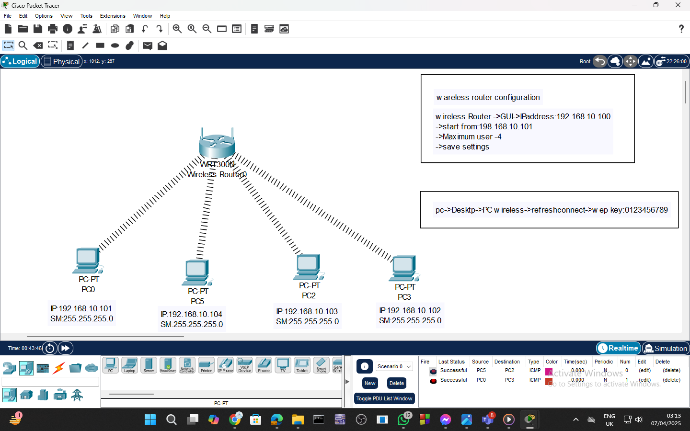

***Two Subnet Network with Router Interconnection***

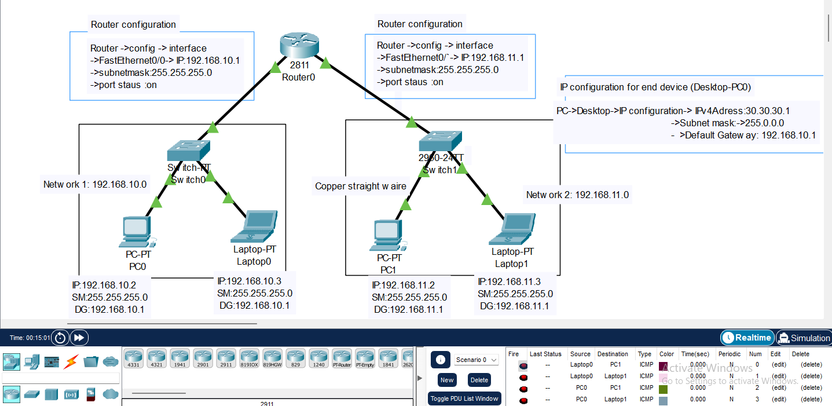

***2 Routers Connecting 2 Networks with Static Routing***

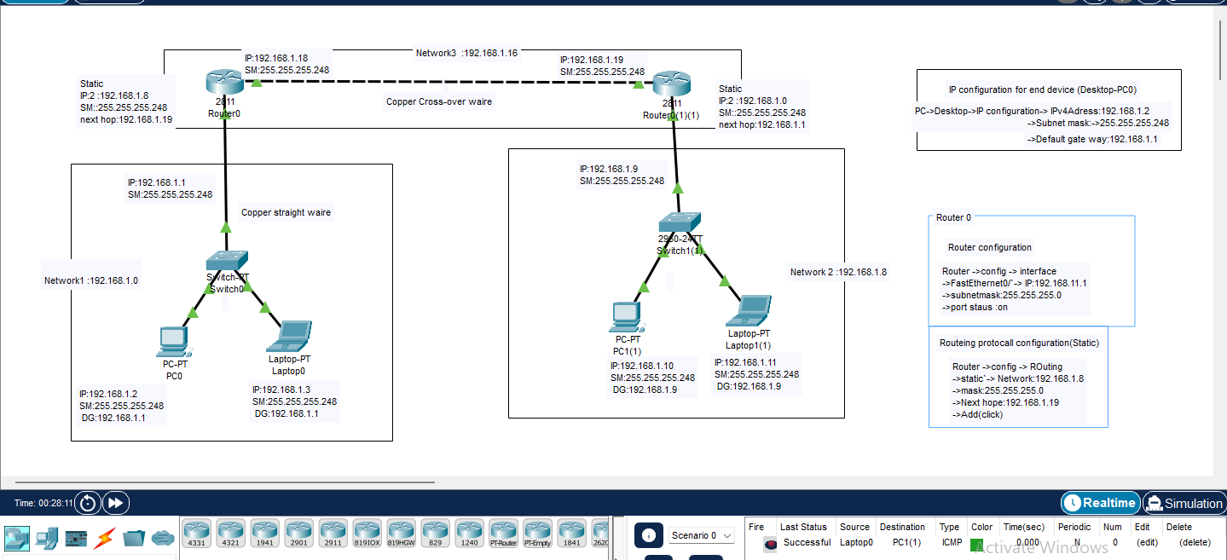

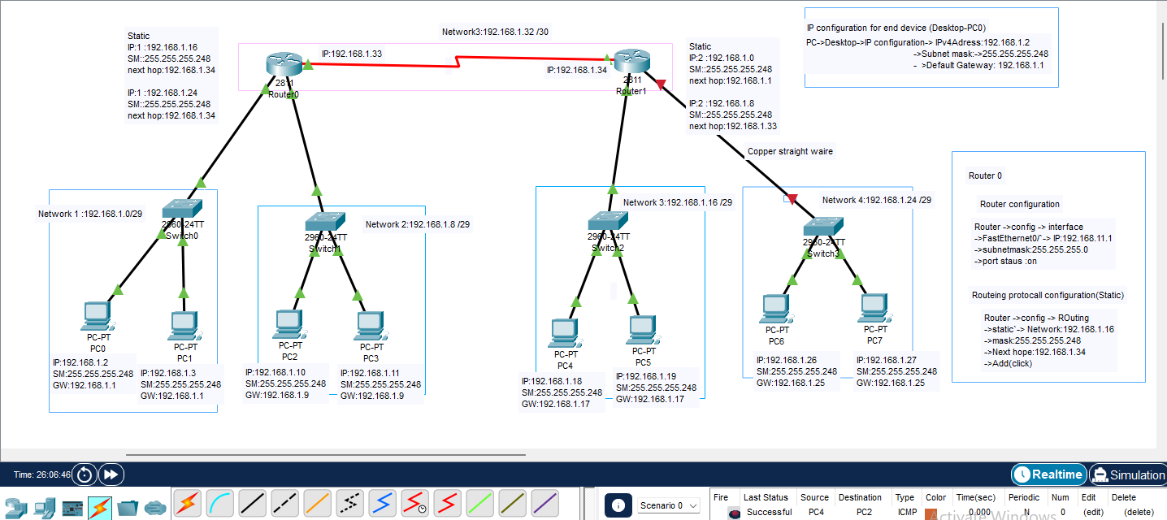

Part:2

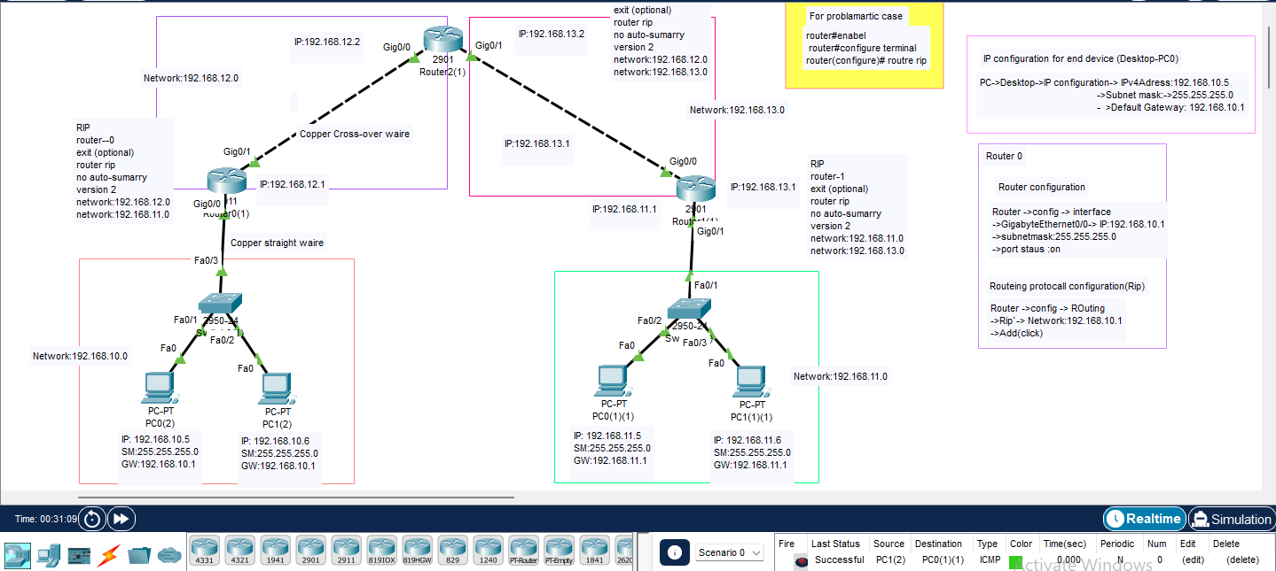

Last lab :